Week 1 – A tale of two cubes

Set Units in Blender
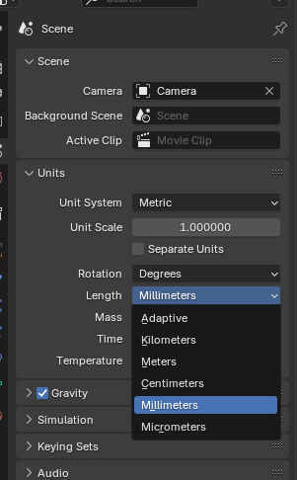
If you need to work with real-world dimensions, such as centimetres or inches, you can adjust the unit settings in the Scene Properties. Set the unit system to Metric and adjust the scale accordingly. For example, setting the scale to 0.001 will make one Blender unit equal to 1 millimetre.

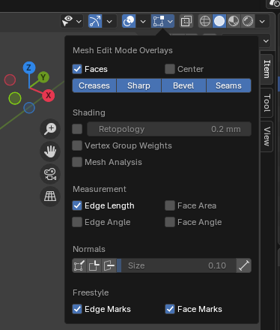

You should also consider turning on measurement overlay in “edit” mode so you can see the length of lines.
In the default theme, this text may be difficult to see. We can go to the preferences and change the theme to make text more visible.
Edit>Preferences>Theme>Install Theme “Deep Grey”
This theme is available for free from Blender Extensions.

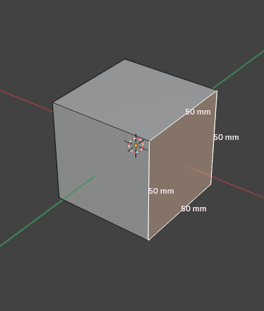
You can now see precise measurements for anything you select. This will be very useful in modelling objects for the real-world.

Resize Object in Blender
To resize an object in Blender, you can use several methods. One common approach is to press the S key, which initiates the scaling operation. Then, you can either type in a specific ratio or move the mouse to scale the object proportionally. If you want to scale the object to a specific dimension, you can first calculate the ratio of the desired size to the current size and then enter that ratio using the number pad while in scaling mode.
Another method involves using the Properties Shelf (N key) to directly input the exact dimensions you want for the object. This allows you to set the X, Y, and Z values precisely without affecting the object's scale.
When dealing with specific dimensions, you can also use the Ctrl+A command to apply the scale, which resets the scale to 1 while keeping the object's dimensions as they are.
You could have done the scaling in Edit Mode directly. Scaling in Edit Mode instead of Object Mode changes the original mesh size while keeping the "outside" scale at 1. This scaling in Edit Mode as well as the other method, using Object Mode and then applying the scale, makes a permanent change in the mesh. The new size is now the basic original size and you cannot simply reverse it by setting the scale back to 1.
In brief:
- Properties Shelf: Use the N key to access the Properties Shelf, where you can set exact dimensions for your object.
- Scene Properties: Adjust the unit settings in the Scene Properties to work with real-world units like centimeters or inches.
- Apply Scale: Use Ctrl+A to apply the scale and reset it to 1, maintaining the object's dimensions.
3D Print Toolbox

With a decent environment to model in, we should immediately install one of the most useful addons for Blender for anyone modelling for 3D Print – the 3D Print Toolbox.

This addon does a fantastic job of identifying problems in your model before you end up taking them all the way to slicing, saving a great deal of time and effort.

The addon will check any object for:

- Non manifold edges – holes that expose zero-thickness edges. This is the BIG problem.
- Bad Contiguous Edges - edges where the normals of the faces connected to them are pointing in different directions, causing issues in the mesh topology
- Intersect faces – faces poking through each other. Self-intersecting faces are the big problem here.
- Zero faces - a face that has no area, typically because its vertices lie all in line or are collapsed into a single point.
- Zero edges - edges that are so small they are considered negligible and can cause issues during 3D printing. These edges can be a result of overlapping vertices or very small faces that are too tiny to be useful for printing
- Non-flat faces – faces that are bent without a defining edge, usually caused by the presence of ngons
- Thin faces - faces that may be thinner than can be printed
- Sharp edges – pointy edges too thin for 3D printing, as defined by the Edge Sharp property
- Overhang Faces – faces that exceed allowable overhang angle and will need supports

Obviously these problems can be difficult to identify, and hard to fix. The way to handle such problems starts with avoiding them in the first place by learning to model properly. In the case where this is not possible (such as with a downloaded mesh file) we can learn techniques that will help repair the damage.

Exercise:
Create a calibration cube in both FreeCAD and Blender to compare the differences between CAD and a polygonal modeller.

Resources:
Text On Surface in Blender

