In object mode, turn on “snap to face”
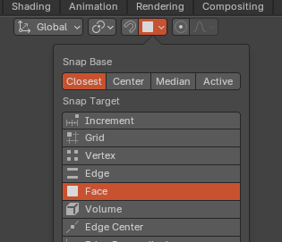
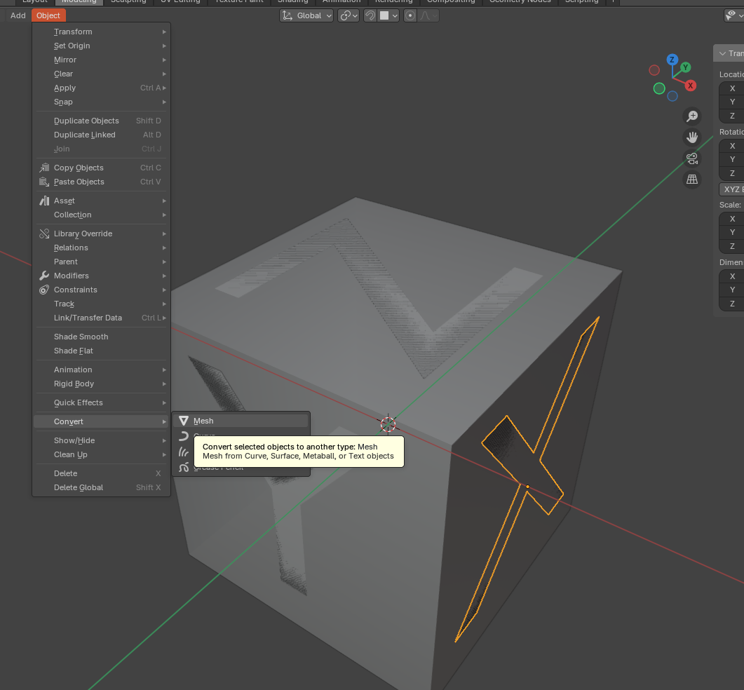
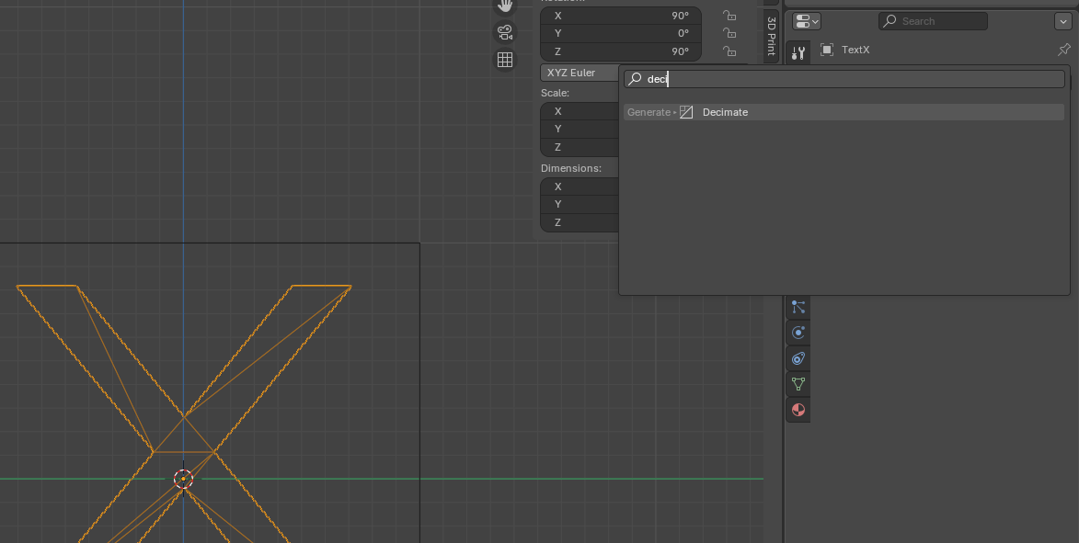
This allows to move the text objects to the surfaces of the cube.Hhhhhh

hkhkhkhk
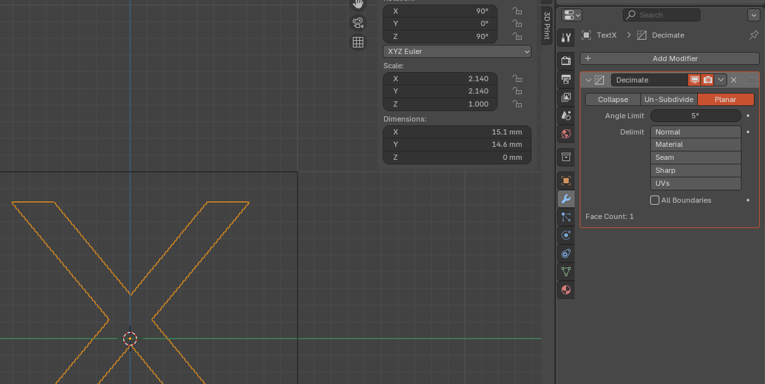
Select “planar”

Cleaning up the Mesh

Extruding and Boolean
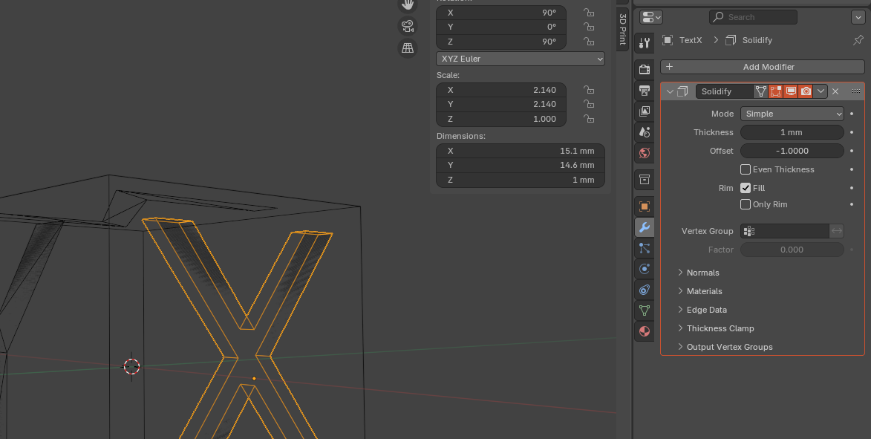
After a boolean operation, it is good to check for potential print problems.
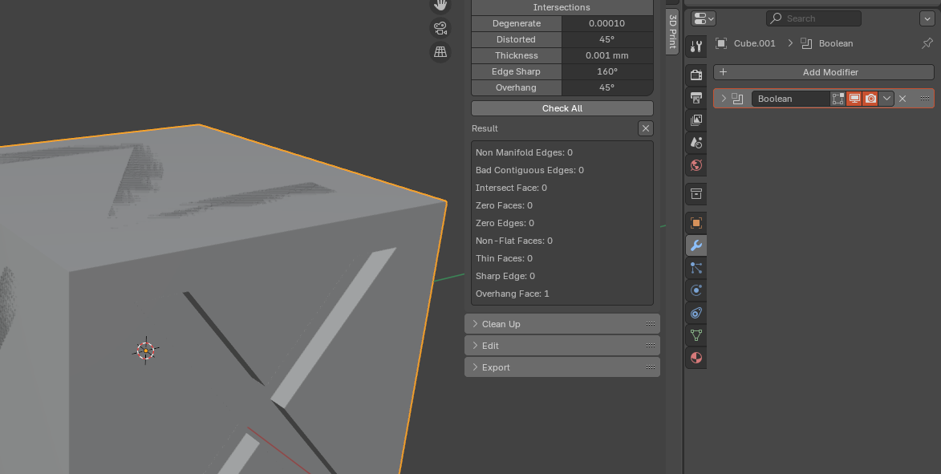
kkjkj

